EXPERIMENT 8

Face and Object Detection

**Aim:**

To perform Face and Object Detection using Haar Cascade and Object Detection using YOLO V5 Deep Learning Library.

**Software/ Packages Used:**

1. Google Colaboratory
2. Libraries used:
   * Opencv – python
   * Numpy
   * Matplotlib
   * tensorflow

**Programs:**

**Haar Cascade Based Object Detection:**

import cv2 import os import time

#myPath = 'data/images' # Rasbperry Pi: '/home/pi/Desktop/data/images' myPath = r'C:\Users\PycharmProjects\Expt8\image'

#cameraNo = 0

cameraBrightness = 180

moduleVal = 10 # SAVE EVERY iTH FRAME TO AVOID REPETITION minBlur = 500 # SMALLER VALUE MEANS MORE BLURRINESS PRESENT grayImage = False # IMAGES SAVED COLORED OR GRAY

saveData = True # SAVE DATA FLAG showImage = True # IMAGE DISPLAY FLAG imgWidth = 180

imgHeight = 120 global countFolder

cap = cv2.VideoCapture(0,cv2.CAP_DSHOW) cap.set(3, 640)

cap.set(4, 480)

cap.set(10, cameraBrightness) count = 0

countSave = 0

def saveDataFunc():

global countFolder countFolder = 1

while os.path.exists(myPath + str(countFolder)): countFolder += 1

os.makedirs(myPath + str(countFolder)) if saveData: saveDataFunc()

while True:

success, img = cap.read()

img = cv2.resize(img, (imgWidth, imgHeight))

if grayImage: img = cv2.cvtColor(img, cv2.COLOR_BGR2GRAY) if saveData:

blur = cv2.Laplacian(img, cv2.CV_64F).var() if count % moduleVal == 0 and blur > minBlur:

nowTime = time.time() cv2.imwrite(myPath + str(countFolder) +

'/' + str(countSave) + "_" + str(int(blur)) + "_" + str(nowTime) + ".png", img) countSave += 1

count += 1

if showImage:

cv2.imshow("Image", img)

#if cv2.waitKey(1) & amp; 0xFF == ord('q'):

if cv2.waitKey(1) & 0xFF == ord('q'):

break cap.release()

cv2.destroyAllWindows() import cv2

#path = 'Resources/haarcascades/haarcascade_frontalface_default.xml' # PATH OF THE CASCADE

path = r'C:\Users\PycharmProjects\Expt8\HaarCascade calssifier\cascade\classifier\cascade.xml'

cameraNo = 0 # CAMERA NUMBER

#objectName = 'Arduino' # OBJECT NAME TO DISPLAY objectName = 'File'

frameWidth = 640 # DISPLAY WIDTH frameHeight = 480 # DISPLAY HEIGHT color = (255, 0, 255)

cap = cv2.VideoCapture(cameraNo) cap.set(3, frameWidth)

cap.set(4, frameHeight) def empty(a):

pass

# CREATE TRACKBAR

cv2.namedWindow("Result")

cv2.resizeWindow("Result", frameWidth, frameHeight + 100) cv2.createTrackbar("Scale", "Result", 400, 1000, empty)

cv2.createTrackbar("Neig", "Result", 8, 50, empty)

cv2.createTrackbar("Min Area", "Result", 0, 100000, empty)

cv2.createTrackbar("Brightness", "Result", 180, 255, empty) # LOAD THE CLASSIFIERS DOWNLOADED

cascade = cv2.CascadeClassifier(path) while True:

# SET CAMERA BRIGHTNESS FROM TRACKBAR VALUE

cameraBrightness = cv2.getTrackbarPos("Brightness", "Result") cap.set(10, cameraBrightness)

# GET CAMERA IMAGE AND CONVERT TO GRAYSCALE

success, img = cap.read()

gray = cv2.cvtColor(img, cv2.COLOR_BGR2GRAY) # DETECT THE OBJECT USING THE CASCADE

scaleVal = 1 + (cv2.getTrackbarPos("Scale", "Result") / 1000) neig = cv2.getTrackbarPos("Neig", "Result")

objects = cascade.detectMultiScale(gray, scaleVal, neig) # DISPLAY THE DETECTED OBJECTS

for (x, y, w, h) in objects: area = w * h

minArea = cv2.getTrackbarPos("Min Area", "Result") if area > minArea:

cv2.rectangle(img, (x, y), (x + w, y + h), color, 3)

cv2.putText(img, objectName, (x, y - 5), cv2.FONT_HERSHEY_COMPLEX_SMALL, 1, color, 2) roi_color = img[y:y + h, x:x + w]

cv2.imshow("Result", img)

if cv2.waitKey(1) & 0xFF == ord('q'):

# if cv2.waitKey(1) & amp: 0xFF == ord('q'): Break

**Output:**

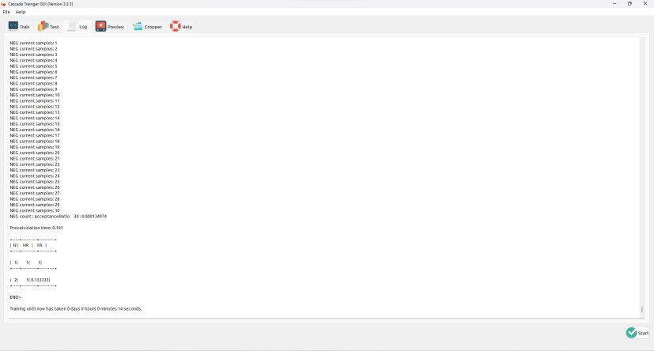

**OUTPUT**

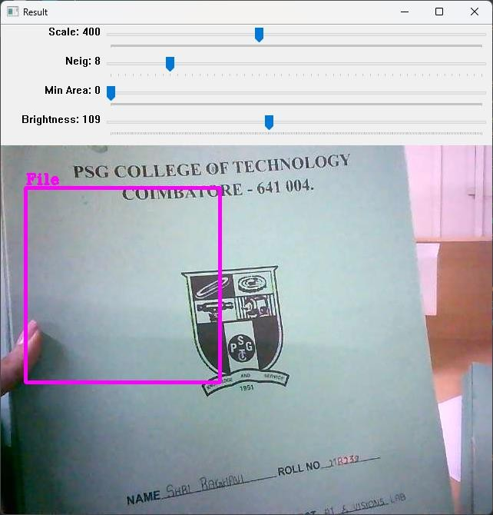

**HAAR CLASSIFIER**

import cv2

face_classifier = cv2.CascadeClassifier(cv2.data.haarcascades + "haarcascade_frontalface_default.xml")

eye_classifier = cv2.CascadeClassifier(cv2.data.haarcascades + "haarcascade_eye.xml") # capture frames from a camera

cap = cv2.VideoCapture(0,cv2.CAP_DSHOW)

# loop runs if capturing has been initialized. while 1:

# reads frames from a camera ret, img = cap.read()

# convert to gray scale of each frames

gray = cv2.cvtColor(img, cv2.COLOR_BGR2GRAY)

# Detects faces of different sizes in the input image faces = face_classifier.detectMultiScale(gray, 1.3, 5)

for (x, y, w, h) in faces:

# To draw a rectangle in a face

cv2.rectangle(img, (x, y), (x + w, y + h), (255, 255, 0), 2) roi_gray = gray[y:y + h, x:x + w]

roi_color = img[y:y + h, x:x + w]

# Detects eyes of different sizes in the input image eyes = eye_classifier.detectMultiScale(roi_gray)

# To draw a rectangle in eyes for (ex, ey, ew, eh) in eyes:

cv2.rectangle(roi_color, (ex, ey), (ex + ew, ey + eh), (0, 127, 255), 2)

# Display an image in a window cv2.imshow('img', img)

# Wait for Esc key to stop

if cv2.waitKey(1) & 0xFF == ord('q'): break

# Close the window cap.release()

# De-allocate any associated memory usage cv2.destroyAllWindows()

**Output Image**:

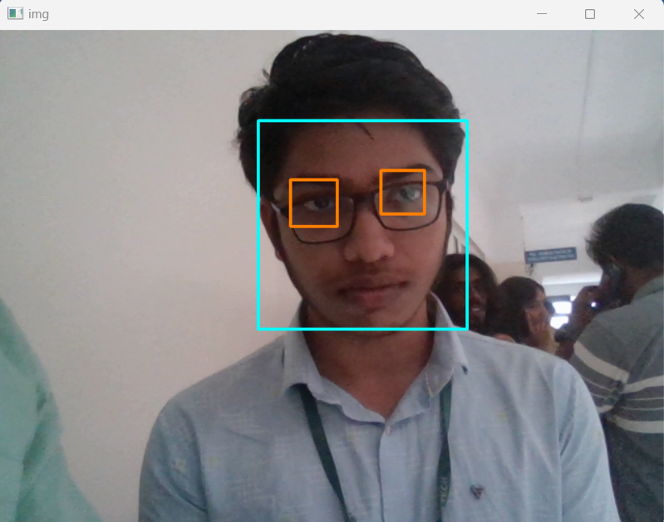

**YOLO v5 Based Object Detection: (both for pretrained and custom data- (i/p - Video, Image, Live Video))**



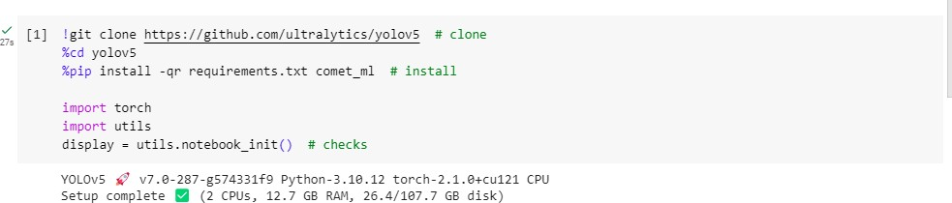

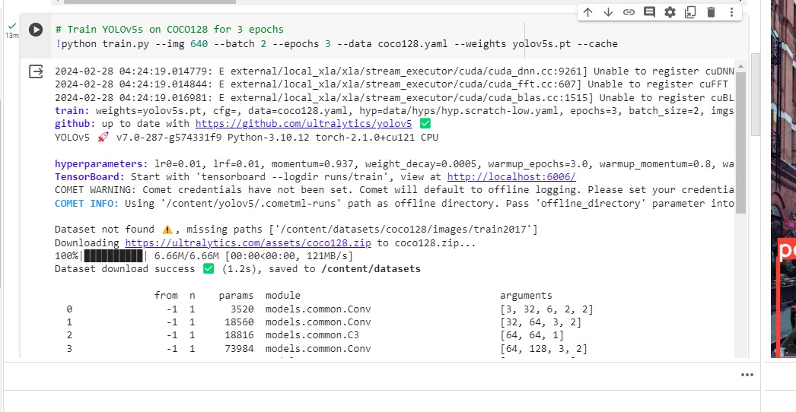

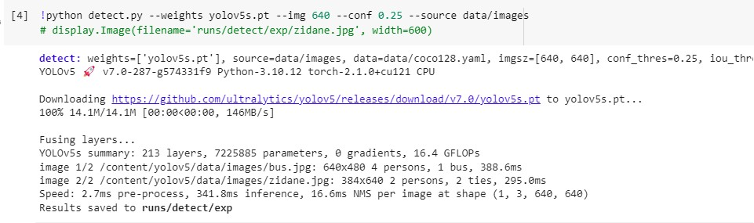

**Input Image Output Image**

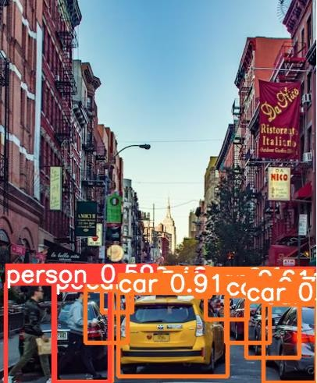

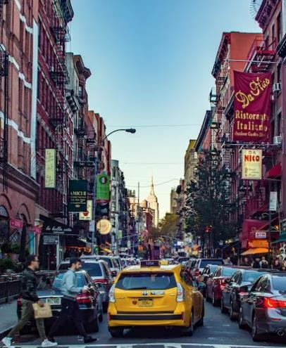

II

**Input Image Output Image**

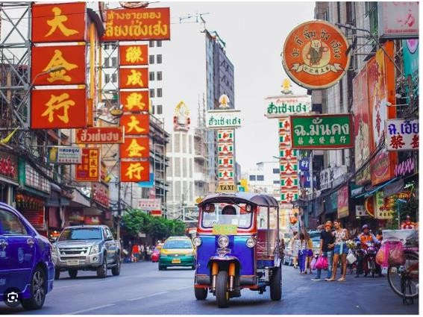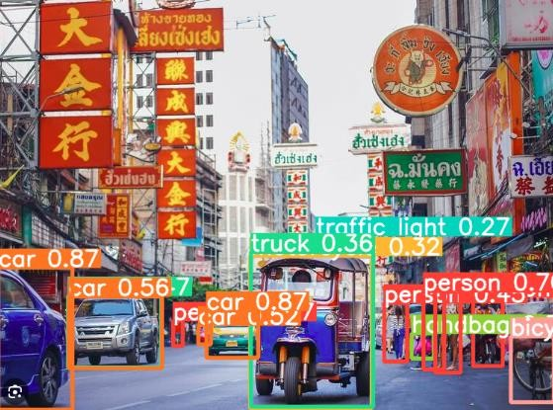

**Live Video:**

* Data set is collected and annotated using MakeSense Ai

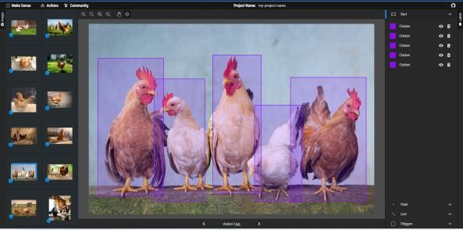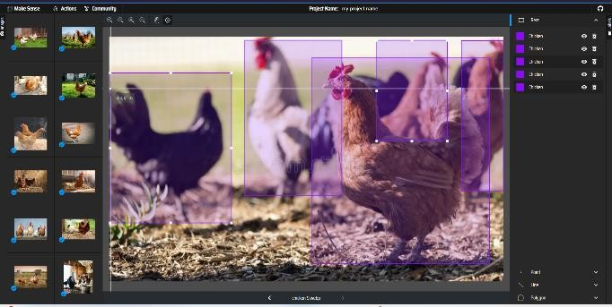

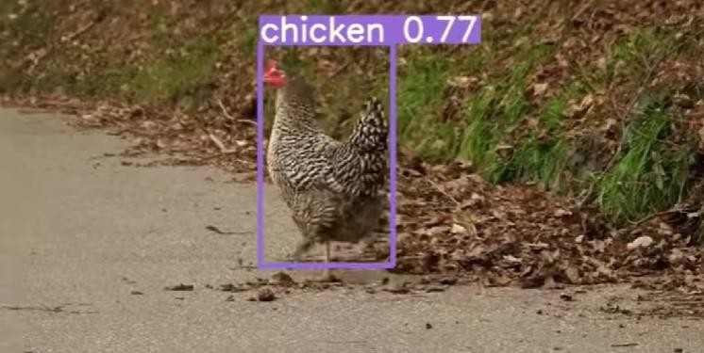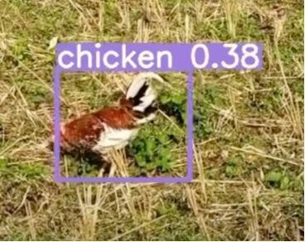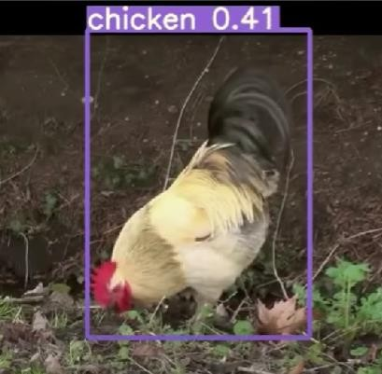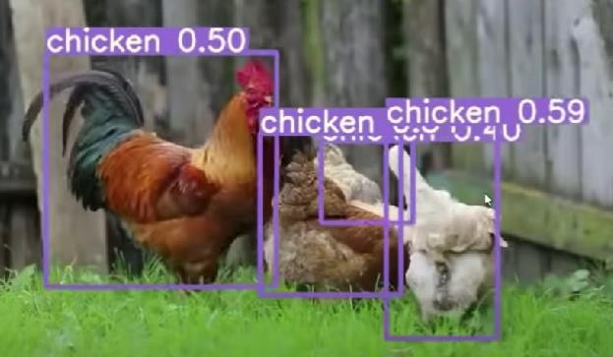**Output:**

**Custom data live video capture**

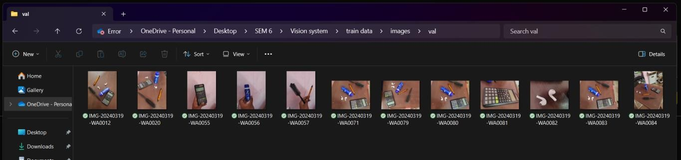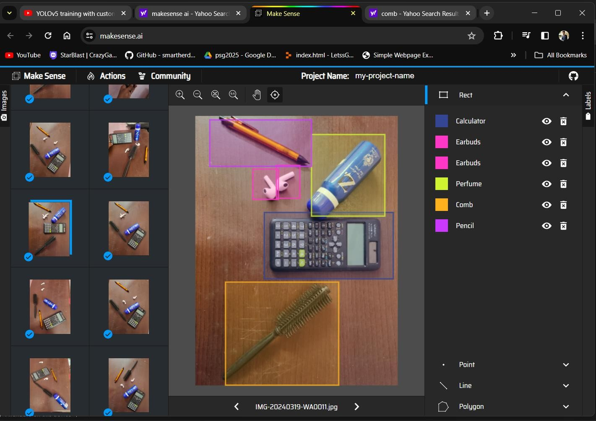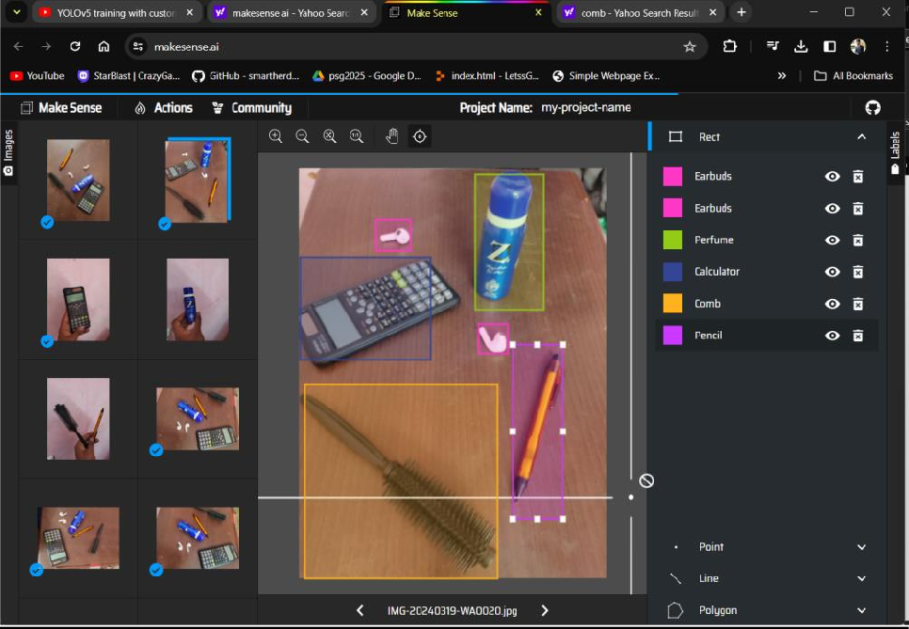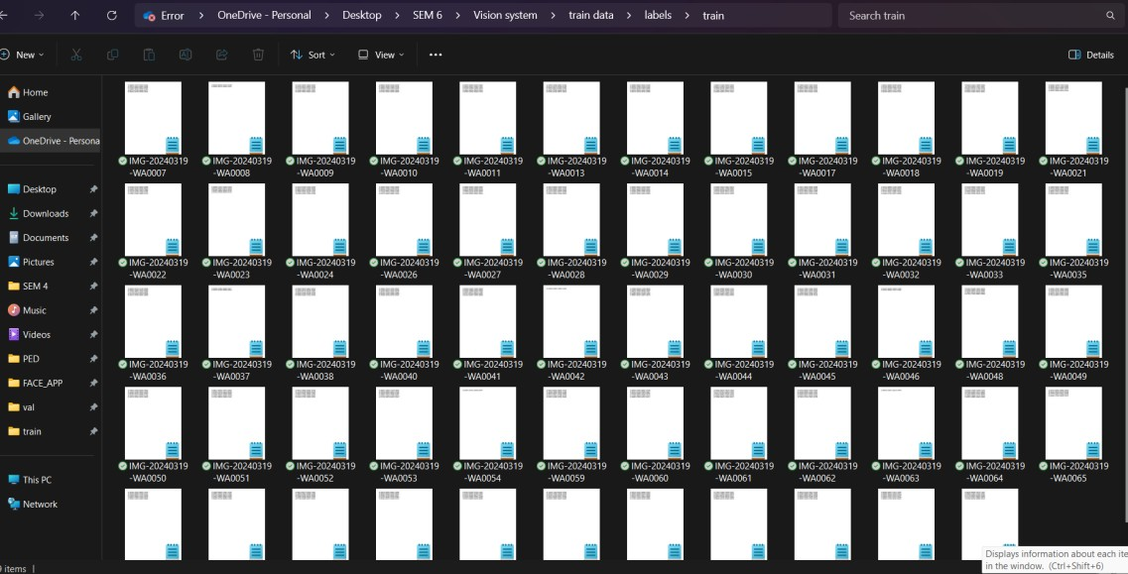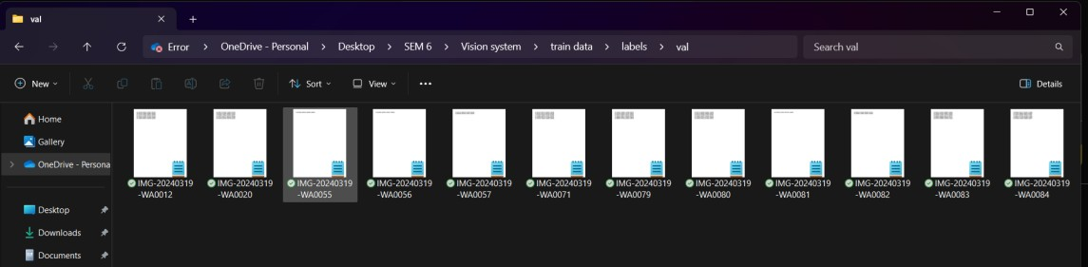

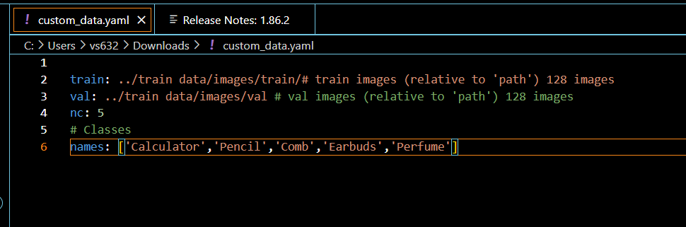

**Object Detection using Deep Learning camera:**

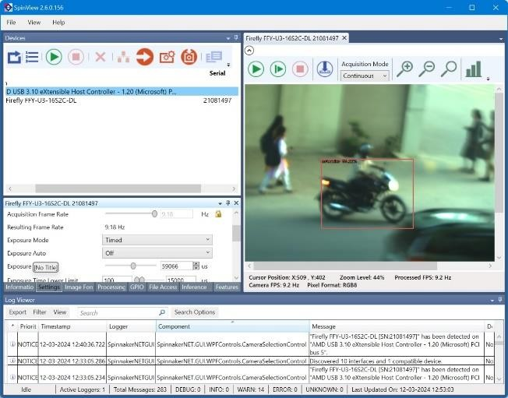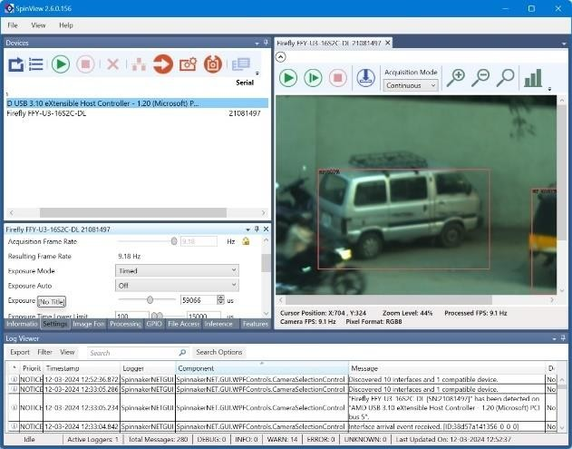

**Post Lab Questions**

1. **What are the key advantages of using Haar Cascades for face detection compared to other methods?**

**Fast Processing**: Haar cascades are computationally efficient, making them suitable for real-time applications.

**Robustness:** They can detect faces under various conditions such as changes in lighting, facial expressions, and minor occlusions.

**Pre-trained Models**: Haar cascades come with pre-trained models for face detection, saving time and computational resources during implementation.

**Simple Implementation**: Haar cascades are relatively simple to implement and understand, making them accessible to developers with varying levels of expertise.

1. **What are the difference between ANN & CNN.**

|  |  |  |  |
| --- | --- | --- | --- |
| **Feature** |  | **Artificial Neural Network (ANN)** | **Convolutional Neural Network (CNN)** |
| **Architecture** |  | Consists of interconnected layers of neurons, including input, hidden, and output layers. | Employs specialized layers such as convolutional, pooling, and fully connected layers. |
| **Feature Learning** |  | Not specifically designed for feature extraction from structured data like images. | Specifically designed for feature extraction from images, utilizing convolutional layers. |
| **Parameter Sharing** |  | Each neuron in one layer is connected to every neuron in the subsequent layer, leading to a large number of parameters. | Utilizes parameter sharing and local connectivity through convolutional layers, reducing the number of parameters. |
| **Application** |  | Widely used in various tasks such as classification, regression, and clustering across different domains. | Particularly effective in image recognition, object detection, and tasks involving spatial data analysis. |

1. **For the following image perform the convolution operation. Also perform Max pooling, Min pooling and Average pooling on the input image.**

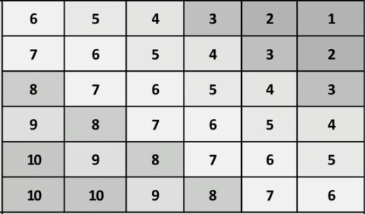

|  |  |  |
| --- | --- | --- |
| 3 | 2 | 4 |
| 2 | 0 | 2 |
| 4 | 2 | 3 |

**Convolution Output:**

[132 110 88 66]

[154 132 110 88]

[176 154 132 110]

[194 176 154 132]

# Max Pooling With pool size(2x2)

[7,5,3]

[9,7,5]

[10,9,7]

# Min Pooling With pool size(2x2)

[5,3,1]

[7,5,3]

[9,7,5]

# Average Pooling With pool size(2x2)

[6,4,2]

[8,6,4]

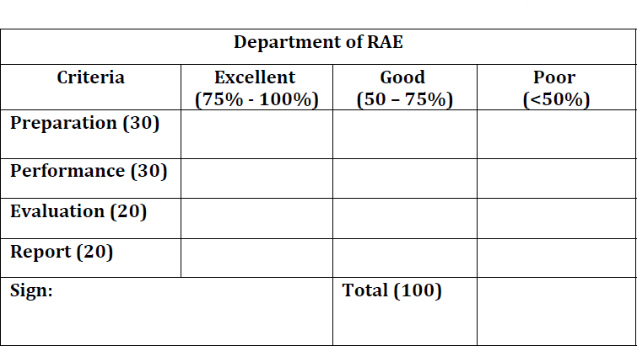[9.75,8,6]

**Result:**

Thus Face Detection using Haar Cascade and Object Detection using Yolo V5 were performed.